Regulations:
A18

H.T No

Sreenidhi Institute of Science and Technology
(An Autonomous Institution)
Code No: 7HC12 Date: 23-Dec-2019 (FN)

B.Tech II-Year I-Semester External Examination, Dec-2019/Jan-2020 (Regular)
ENGINEERING MATHEMATICS-III (CIVIL & me)

Time: 3 Hours Max.Marks:70

Note: a) No additional answer sheets will be provided.
b) All sub-parts of a question must be answered at one place only, otherwise it will not be valued.
c) Missing data can be assumed suitably.

Part - A Max.Marks:20

Answer all QUESTIONS.

1. | Form a partial differential equation by eliminating the arbitrary function 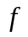 from 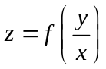. | [2M]
2. | Classify the partial differential equation 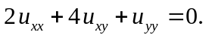 | [2M]
3. | State Baye’s theorem. | [2M]
4. | What is an estimation? In how many ways estimation can be done? | [2M]
5. | Define Type-I and Type-II errors. | [2M]
6. | Write the assumptions for t-test. | [2M]
7. | Find the complete integral of 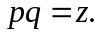 | [2M]
8. | A random variable X has a poisson distribution such that  P(X=1) = P(X=2) .Find the mean of the distribution. | [2M]
9. | Write about  test for independence of attributes. | [2M]
10. | Solve the partial differential equation 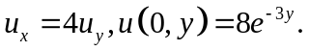 | [2M]

Part – B Max.Marks:50
ANSWER ANY FIVE QUESTIONS. EACH QUESTION CARRIES 10 MARKS.

11. | a) | Solve the partial differential equation 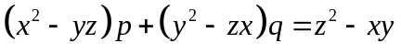. | [5M]
 | b) | Reduce the partial differential equation 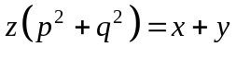 to separable form and hence solve it. | [5M]
12. |  | Find the solution of Laplace equation 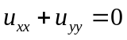 which satisfies  the conditions 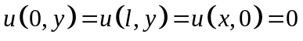and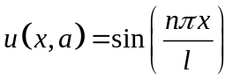. | [10M]
13. | a) | A random variable  has the following probability distribution :  Find i) the value of k ii) E(X) and iii) V(X) . | [5M]
  X : | 0 | 1 | 3 | 4 | 5 | 6 | 7
  P(X): | 0 | k | 2k | 2k | 3k | k² | 7k² +k
 | b) | In a distribution which is exactly normal, 12% of the items are under 30 and 85% are under 60. Find the mean and standard deviation of the distribution. | [5M]
14. | a) | A population consists of four numbers 2, 3, 4, 5. Consider all possible distinct samples of size two without replacement. Determine a) the population mean b) the population standard deviation. | [6M]
 | b) | Write short notes on interval estimation and point estimation. | [4M]
15. | a) | Explain the procedure for hypothesis testing. | [5M]
 | b) | A random sample of 100 students gave a mean height of 58 kgs with standard deviation 4 kgs. Test at 5% level of significance the hypothesis that the mean weight in the population is 60 kgs. | [5M]
16. | a) | Two independent samples of and times respectively had the following values of variables.  Do the estimates of population variance differ significantly? | [5M]
  Sample I: | 9 | 11 | 13 | 11 | 15 | 9 | 12 | 14
  Sample II: | 10 | 12 | 10 | 14 | 9 | 8 | 10 | -
 | b) | A random sample of boys had the following  Do these data support the assumption of population mean (Tabulated value 2.262) | [5M]
17. | a) | Solve 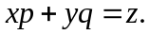 | [2M]
 | b) | Find the solution of one dimensional heat equation. | [5M]
 | c) | If X is a discrete random variable and k is a constant,  prove that 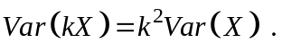 | [3M]
18. | a) | A random sample of size 81 is taken from an infinite population having the mean 65 and standard deviation 10. Find the probability that will be between 66 and 68. | [4M]
 | b) | Write about one tailed test and two tailed test. | [3M]
 | c) | Explain briefly the F-test. | [3M]

-- 00 -- 00 –

